Cairo university
Biomedical engineering biostatistics research

Abstract- The upcoming research article indicates both the correlation coefficient of a sample of genes found In human bodies which was found by Hugo gene and will be used to get the correlation of the dataset and its hypothesis test

Index Terms- About four key words or phrases in alphabetical order, separated by commas. Keywords are used to retrieve documents in an information system such as correlation, hypothesis, genes.

I. INTRODUCTION

This article guides a stepwise walkthrough by biomedical engineering Cairo university for finding the correlation coefficient of a sample. In addition to getting the hypothesis test of that sample of genes. Now, here we enlist the proven steps to publish the research paper in a journal.

Identify the constructs of a Research – Essentially a Research consists of three major sections. The import of the data into the python files program used as Vs code or PyCharm. The correlation coefficient, the hypothesis test

II. Importing the data into text editor [correlation]

A. implementing the data into excel file
First the two samples were downloaded then opened as excel files 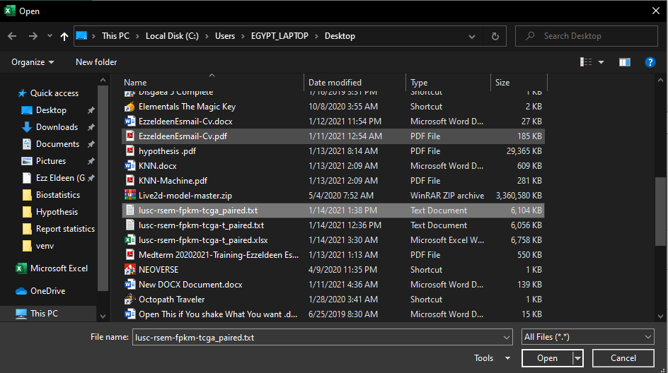
After that we had to go through some research of how to implement the data into PyCharm or Vs code so we found a similar question in Stack overflow that uses two libraries pandas or Xlsx writer, and we decided to go with the pandas library.
B. coding for reading the data
We then used the pandas to read the excel file that was made 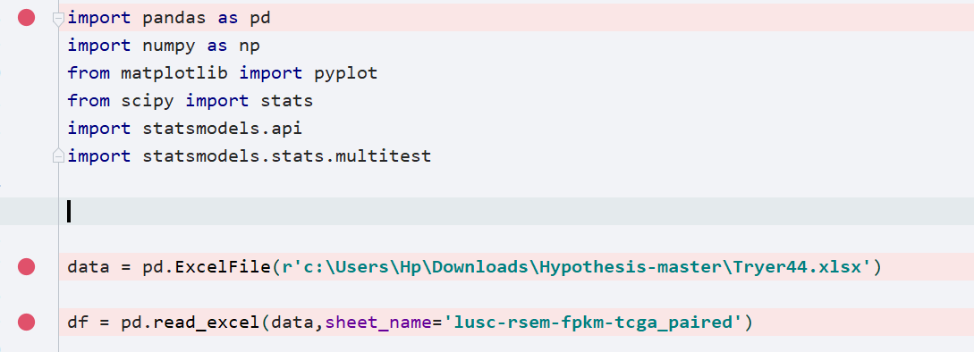
Were data and df is the reader of the excel files and done the same thing for the two excel files.

C. Calculating the correlation
We searched and found out we could use two methods for calculating the correlation either Pearson or we could use spearman and for simplified usage we used NumPy library which is embedded as Pearson and by using a for loop that iterates over all rows of both excel files we could calculate the correlation 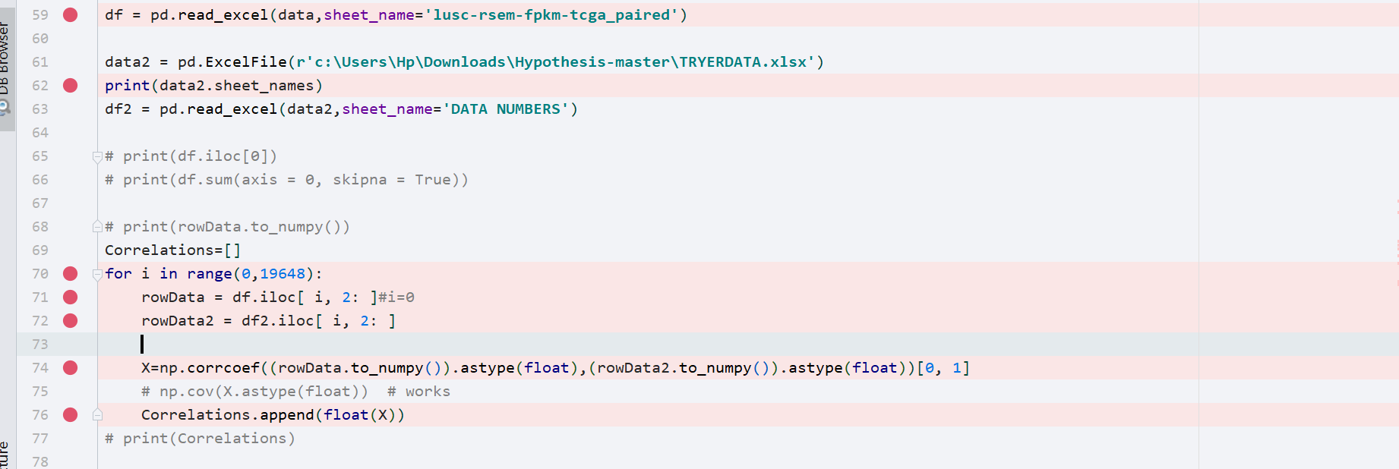

D. Writing new excel
And by the writer function implemented in pandas we could save a new file with correlation of each gene.
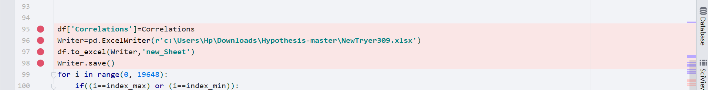
A. Plotting of the max and min
The plotting was used as the graph library pyplot which was imported then used for the max and min which was detected by its functions
.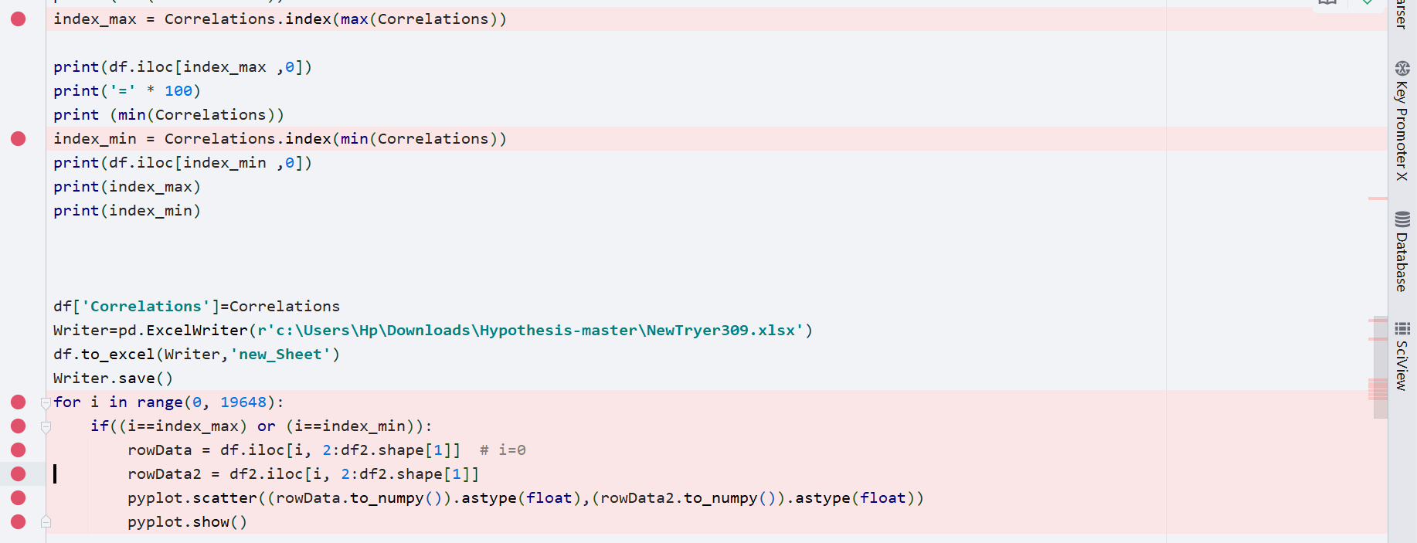

Which its plotting can be seen here
Note :the plot was done after the filter
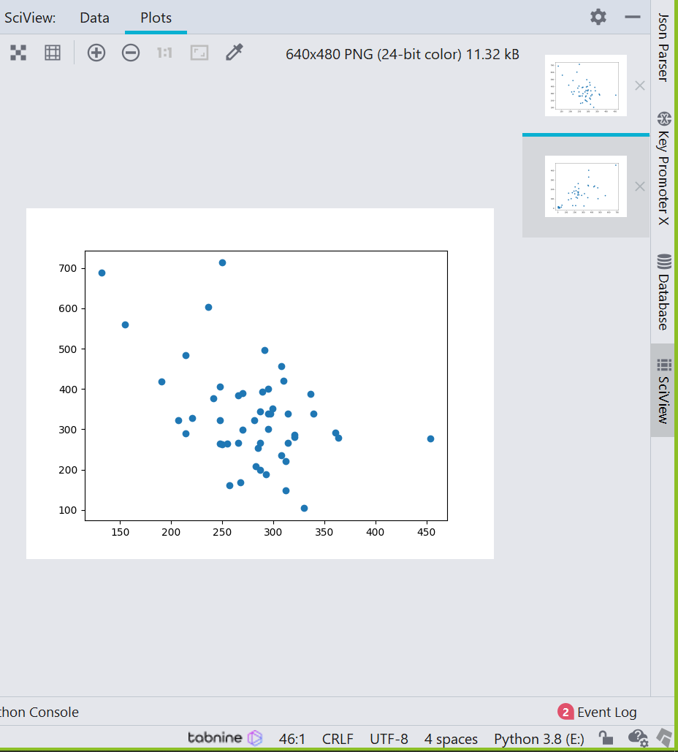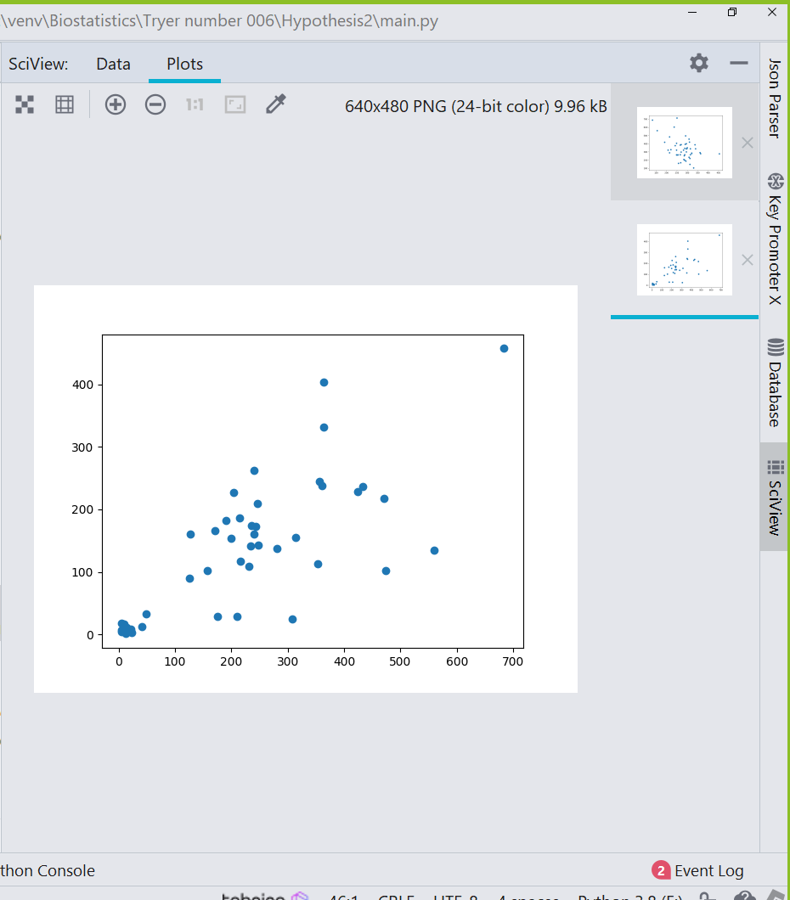

III. hypothesis
A. t-test in both cases [independent-paired]
we have two cases first if the data is independent means they have nothing to do with each other or if the data itself is not independent and we are actually having the same data but after a change for example [Drug effects on mice] so we may have 2 different mice types [independent] or we have the same mice type and we check the drug effects on the same sample.in both cases,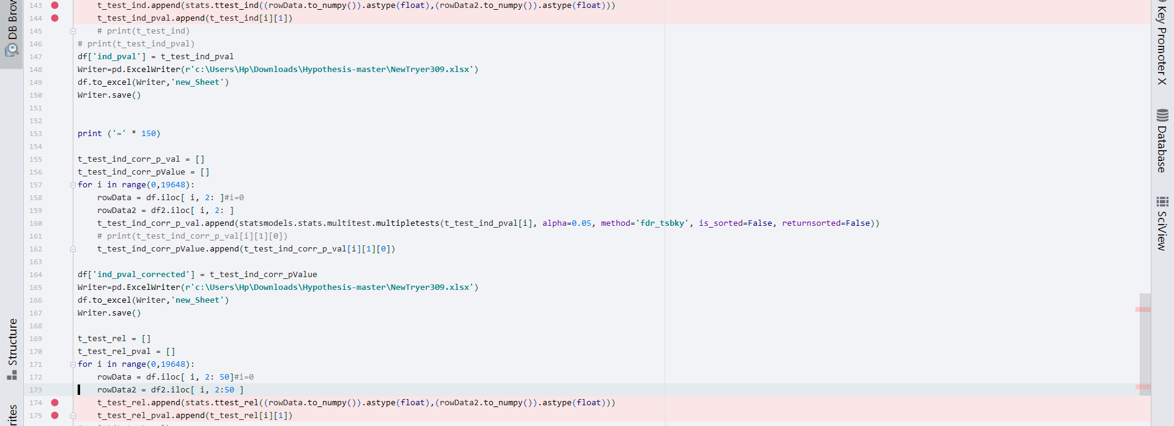

B. FDR regulation
but we had to regulate our P-values because of false positive numbers[the out numbers that is way out of mean that caused the problem itself and rejected the null hypothesis]so we applied the FDR regulation method in both cases which can be seen here

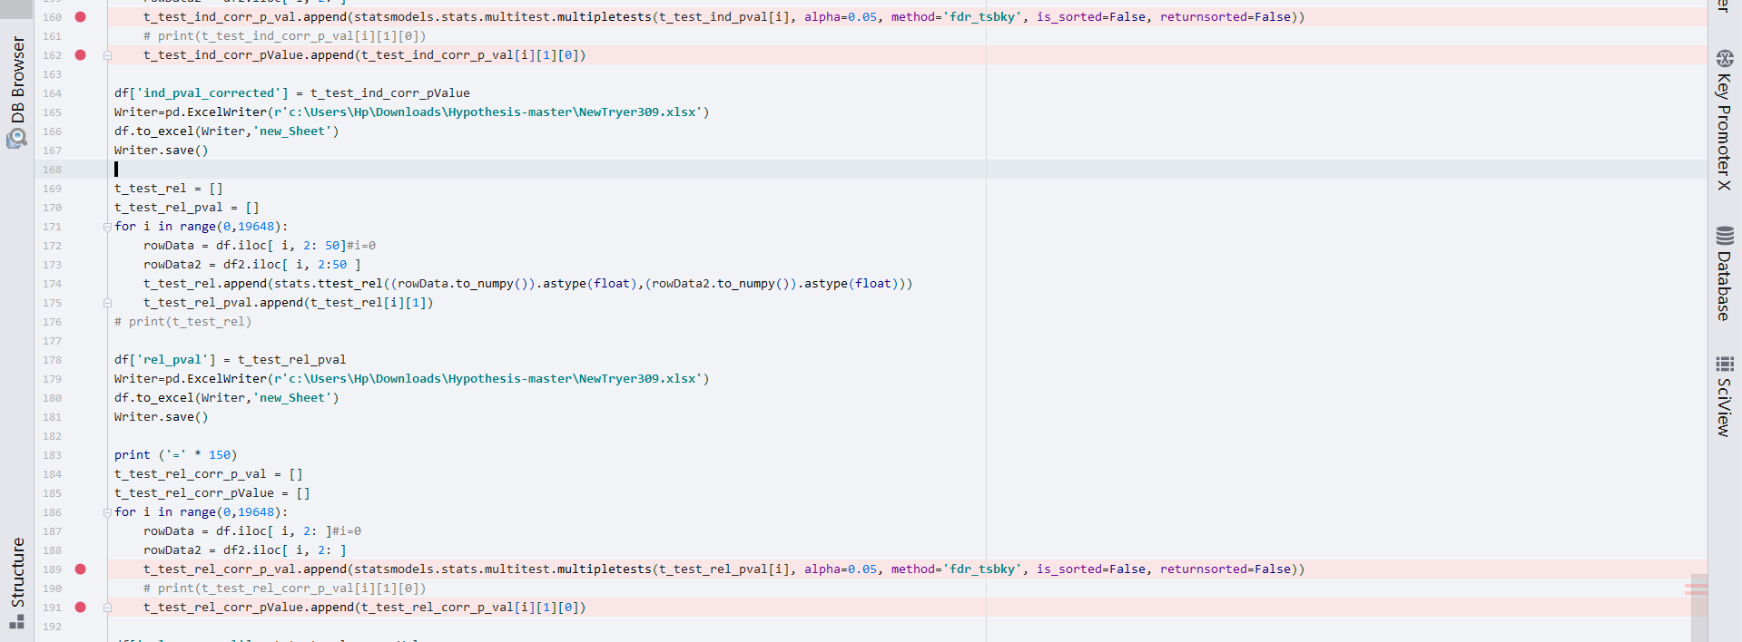

IV. Filter
As it was seen from the data , that Some of its rows aren’t accurate in addition to having a lot of zeros as well so it was seen after the plotting that there was error in the max and min plot so a filter was needed for the zeros and low data values <5
So a filter was made based on these principles which can be seen here.
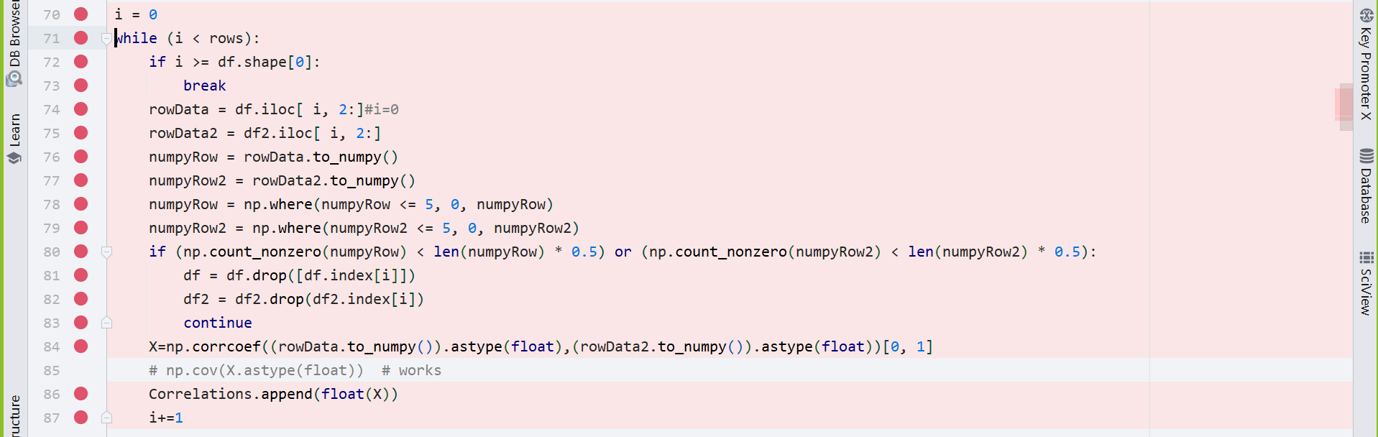

V. unique [distinct] and common genes
Our main file that we made , had all the data that of p-value as a value and the rejection value [True/False] so we found it better to make another python file [main2.py] which will store this [True/false] data and make a counter that calculate their numbers , then made the if statement to identify our unique genes from the common ones, and in the end we stored the data in another excel file which we called [Unique.xlsx]
Which found [Unique] to be 33 [independent]- 37[Paired]
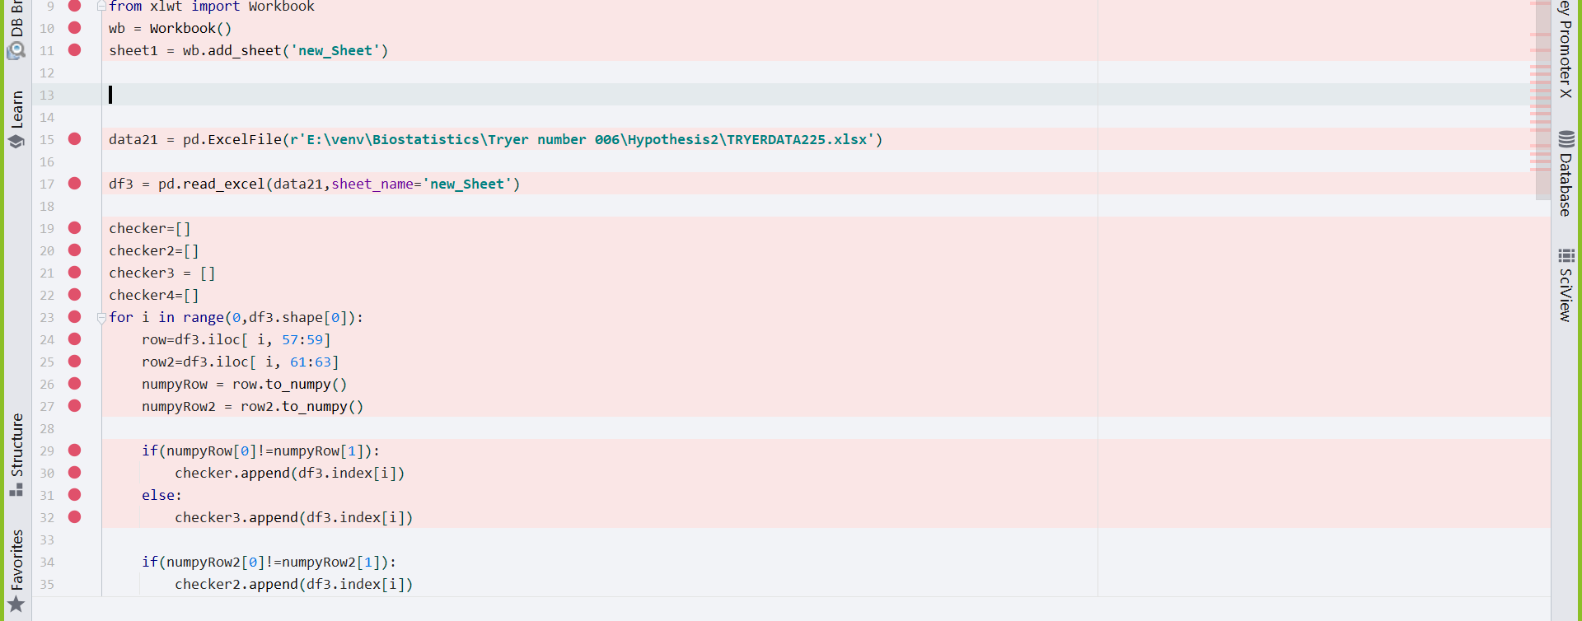
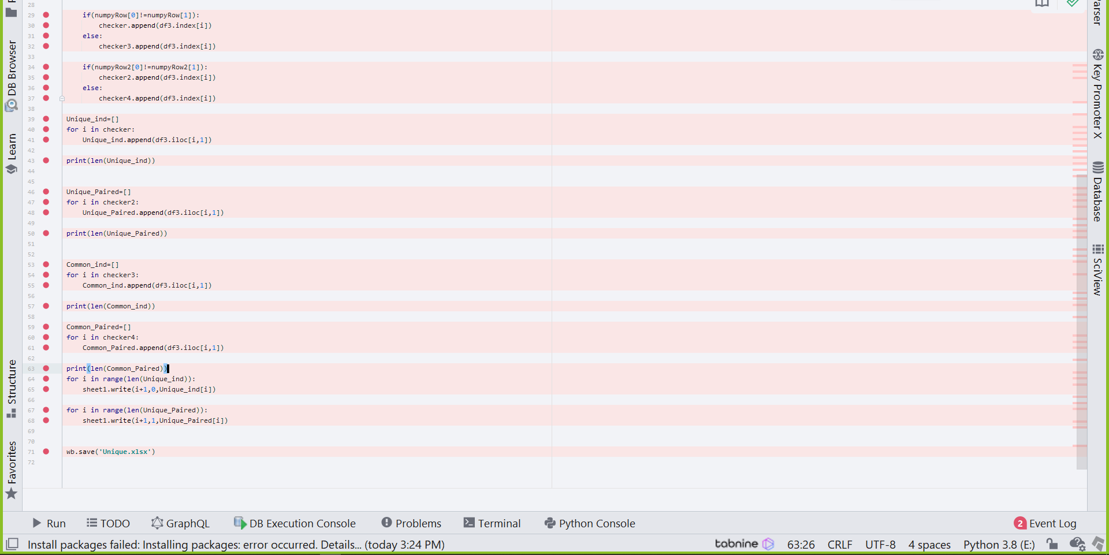

IV. SOME COMMON MISTAKES

- The first mistake was the Filter the last research numbers weren’t wrong but not accurate as there were some data that needed filtration these data which was used for coding and excel files were all before filtration so the team had to calculate all the assumptions from the start using the filtered data which was about 4000 less in numbers than last data as these 4000 number had more 0 than 50 % than the normal data
- Another mistake was the FDR regulation the regulations had different types [methods] which could affect P in different ways based on there principles.
- Another mistake was the difference between our assumption [I] value and the df.index[I] as all our rows index was first shifted.
- The filter numbers had different index than the rows as the rows drops its max number decreases so we calculated them and made a break function for it when it reaches its max I after the drop it will stop the loop.

REFERENCES[used]

- https://www.genenames.org/

- https://pandas.pydata.org/

- https://stackabuse.com/calculating-pearson-correlation-coefficient-in-python-with-numpy/#:~:text=The%20Pearson%20Correlation%20coefficient%20can,sample%20of%20n%20random%20variables

- https://numpy.org/

- https://www.w3schools.com/python/python_ml_scatterplot.asp

- https://stackoverflow.com/questions/57648069/choosing-pandas-over-xlsxwriter-when-working-with-excel-data

- https://www.statsmodels.org/dev/generated/statsmodels.stats.multitest.multipletests.html

- https://stackoverflow.com/questions/11788900/importerror-no-module-named-statsmodels

- https://stackoverflow.com/questions/49814258/statsmodel-attributeerror-module-scipy-stats-has-no-attribute-chisqprob

- https://stackoverflow.com/questions/24808043/importerror-no-module-named-scipy

- https://stackoverflow.com/questions/45670487/numpy-cov-exception-float-object-has-no-attribute-shape

- https://www.geeksforgeeks.org/writing-excel-sheet-using-python/

- https://www.statsmodels.org/dev/generated/statsmodels.stats.multitest.multipletests.html

- https://stackoverflow.com/questions/8364674/how-to-count-the-number-of-true-elements-in-a-numpy-bool-array

- https://www.javaer101.com/en/article/931010.html [0,1]

- https://www.shanelynn.ie/select-pandas-dataframe-rows-and-columns-using-iloc-loc-and-ix/ iloc

- https://stackoverflow.com/questions/45670487/numpy-cov-exception-float-object-has-no-attribute-shape astype[‘float’]

- https://www.w3schools.com/python/numpy_array_sort.asp sort

- https://docs.scipy.org/doc/scipy/reference/generated/scipy.stats.ttest_ind.html

- https://stackoverflow.com/questions/24808043/importerror-no-module-named-scipy

- https://stackoverflow.com/questions/49814258/statsmodel-attributeerror-module-scipy-stats-has-no-attribute-chisqprob

- https://stackoverflow.com/questions/11788900/importerror-no-module-named-statsmodels

- https://www.statsmodels.org/dev/generated/statsmodels.stats.multitest.multipletests.html

group names:

Name | Section | BN
Ezzeldden esmail ezzeldeen | 1 | 50
Yehia osama mohammed | 2 | 47
Abdallah tamer reda | 1 | 48
Ahmed Hossam mohammed | 1 | 2

.
Participation
Ezzeldeen esmail | Import +correlation
Abdallah tamer | Filter + plotting
Yehia and Ahmed Hossam | Hypothesis
all team | Distinct + common genes

